Course Name: |  | Microprocessor and Embedded System | Course Code: | EEE 4103
Semester: |  | Fall 2025-26 | Section: | M
Faculty Member: |  | DEBRAJ DAS
OEL Title: |  | Air Quality Monitoring System
Group #: |  | 06
SL | Student ID # | Student Name | Program | Obtained Marks
1. | 23-52978-3 | MD. TAWFIQUL ISLAM TAMAL | CSE
2. | 23-52980-3 | RAFID HOSSAIN | CSE
3. | 23-52991-3 | MD ABU SIAM | CSE
4. | 23-53029-3 | ASMA AKTHER | CSE
5. | 23-53889-3 | ANIK DEB BISWAS | CSE
6. | 23-53906-3 | NADIM HOSSAIN | CSE

Assessment Materials and Marks Allocation:
COs | CO Statement | Assessment Materials | POIs | Marks
CO1 | Simulate laboratory experiments using microcontrollers, sensors, actuators switches, display devices, etc., and a suitable simulator related to the fields of electrical and electronic engineering. | Open Ended Laboratory Report | P.e.2.P4 | 15

Assessment Rubrics:
COs-POIs | Excellent  [13-15] | Proficient  [10-12] | Good  [7-9] | Acceptable  [4-6] | Unacceptable  [1-3] | No Response  [0] | Secured Marks
CO1  P.e.2.P4 | The OEL was developed as a process for complex engineering problems considering microcontrollers, sensors, switches, display devices, etc. The simulation and implementation processes are demonstrated by combining all input patterns with several outcomes. | The OEL was developed as a process for complex engineering problems considering microcontrollers, sensors, switches, display devices, etc. The simulation and implementation processes are demonstrated with some outcomes and limited input patterns. | The OEL was developed as a process for complex engineering problems considering microcontrollers, sensors, switches, display devices, etc. The simulation and implementation processes are not demonstrated with some outcomes and input patterns. | The OEL was developed as a process for complex engineering problems considering microcontrollers, sensors, switches, display devices, etc. The simulation and implementation processes are not demonstrated with a few outcomes for a few patterns. | The OEL was developed as a process for complex engineering problems considering microcontrollers, sensors, switches, display devices, etc. are not appropriate. The simulation and implementation processes are not demonstrated with any outcomes and not for any pattern. | No Response at all/copied from others/ identical submissions with gross errors/image file printed
Comments |  |  |  |  | Total marks (15)

Experiment Title:
Air Quality Monitoring System

Introduction:
The main objective of this experiment is to design and implement an air quality monitoring system using a microcontroller and gas sensor module. This experiment aims to understand the working principles of gas sensing technology, including detection of gas concentration levels, analog signal processing, and threshold-based alert mechanisms.
Through this experiment, air quality monitoring is practically demonstrated by measuring gas concentration from the surrounding environment and displaying real-time values on an LCD. When the gas level exceeds a predefined safe limit, an automated alert system activates a buzzer. The experiment helps in understanding how sensor-based embedded systems collect, process, and respond to environmental data in real-time safety and monitoring applications.

Theory and Methodology:
Air quality monitoring systems are designed to detect the presence of harmful gases and measure their concentration levels in the surrounding environment. In this experiment, a gas sensor module was used to sense gas concentration by producing an analog output voltage proportional to the amount of gas present in the air. The sensor operates based on changes in electrical resistance when exposed to different gas concentrations.
In this experiment, an Arduino Uno microcontroller board was used as the main processing unit. The gas sensor was connected to the analog input pin of the Arduino. The Arduino continuously reads the sensor output and converts the analog signal into a digital value using its built-in Analog-to-Digital Converter (ADC). The measured gas concentration value is then processed using a predefined threshold-based algorithm.
The system functionality was implemented using the Arduino programming environment. The Arduino compares the sensed gas value with a predefined safe limit. When the gas concentration exceeds the threshold level, the microcontroller activates a buzzer as an alert signal and displays the gas concentration value on an LCD. Based on sensor readings, the system provides real-time monitoring and warning, demonstrating practical implementation of sensor interfacing, data processing, and automated alert mechanisms in embedded systems.

Experimental Circuits & Result:
In this experiment, an Arduino Uno microcontroller board was connected with a potentiometer (used to simulate the gas sensor), an LCD display, and a buzzer using proper resistors and breadboard connections. The potentiometer was connected to the analog input pin of the Arduino, while the LCD and buzzer were connected to the digital pins.
Two main operations were performed:
- Gas Level Monitoring: The potentiometer continuously varied its resistance to simulate different gas concentration levels. The Arduino read the analog value from the potentiometer and displayed the corresponding AQI value on the LCD in real time. This allowed the system to show the current air quality condition directly on display.
- Alert Activation: When the simulated gas level crossed the predefined safe threshold, the Arduino activated the buzzer to produce a warning sound. At the same time, the LCD displayed the message “Hazardous” along with the AQI value, alerting the user that the air quality had reached a dangerous level. When the value remained within the safe range, the LCD displayed “Safe & Clean”, and the buzzer stayed OFF.

The system was tested by adjusting the potentiometer to change the simulated gas level and observing the LCD readings and buzzer response. The results confirmed that the system correctly identified safe and hazardous conditions, updated the LCD display accordingly, and activated the buzzer only when the air quality became unsafe.

Figure 1: When the push button on the Master Arduino was pressed

Figure 2: When the push button on the Slave Arduino was pressed
As shown in Figures 1, 2, and 3, an object was placed in front of the sonar sensor while the circuit was running. When the object was far within the sensor’s range (between 50 cm and 80 cm), only the green LED turned ON, indicating that the object was at a safe distance. When the object moved closer (between 30 cm and 50 cm), the yellow and red LEDs turned ON together, showing that the object was getting nearer to the sensor. Finally, when the object came very close to the sensor (less than 30 cm), all three LEDs—green, yellow, and red—glowed at the same time, signaling that the object was at a very short distance.

Figure 2: When the push button on the Master Arduino was pressed

As shown in Figures 3 and 4, when the code starts running, the Arduino microcontroller begins monitoring the air quality by continuously reading data from the potentiometer, which simulates the gas sensor output. The potentiometer provides an analog value representing the gas concentration in the surrounding environment, and this value is sent to the Arduino. Based on this reading, the system updates the LCD display and controls the alert component (buzzer).
When the air quality is within the safe range (Figure 3), the Arduino displays the gas concentration value on the LCD along with the message “Safe & Clean”. In this condition, the buzzer remains OFF, indicating that the air quality is safe and no alert is required.
When the gas concentration increases and crosses the predefined threshold level (Figure 4), the Arduino identifies the air quality as unsafe. In response, the LCD displays the message “Hazardous” along with the gas value. At the same time, the buzzer is activated, confirming that the air quality has reached a dangerous level and immediate attention is required.

Simulation Circuits & Result:
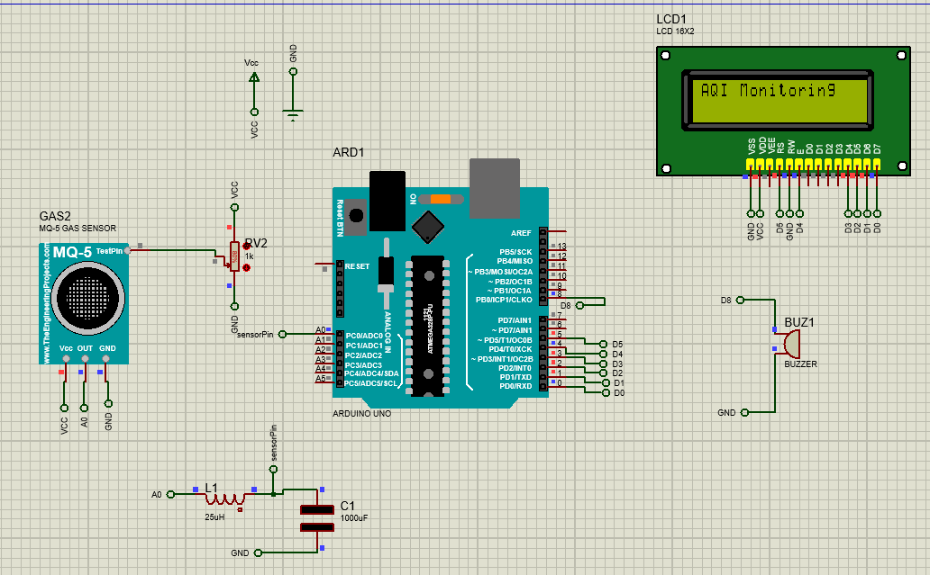

Figure 3: Proteus Simulation of AQI Monitoring System

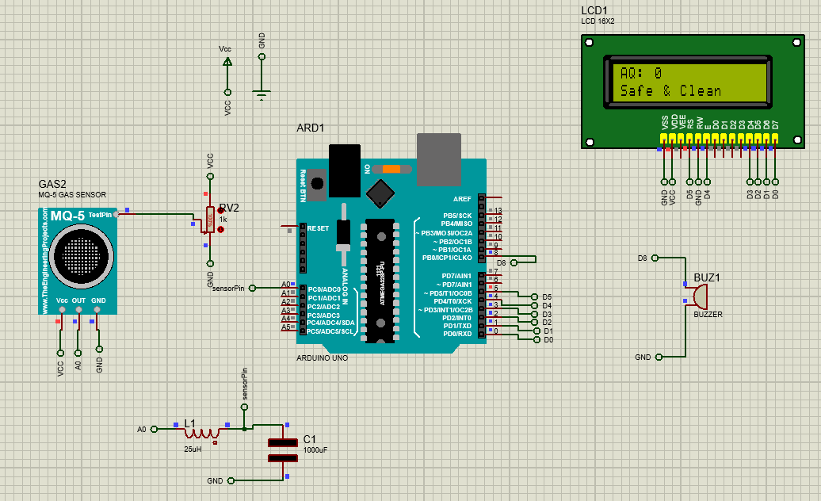

Figure 4: Proteus Simulation When AQI is Safe and Clean

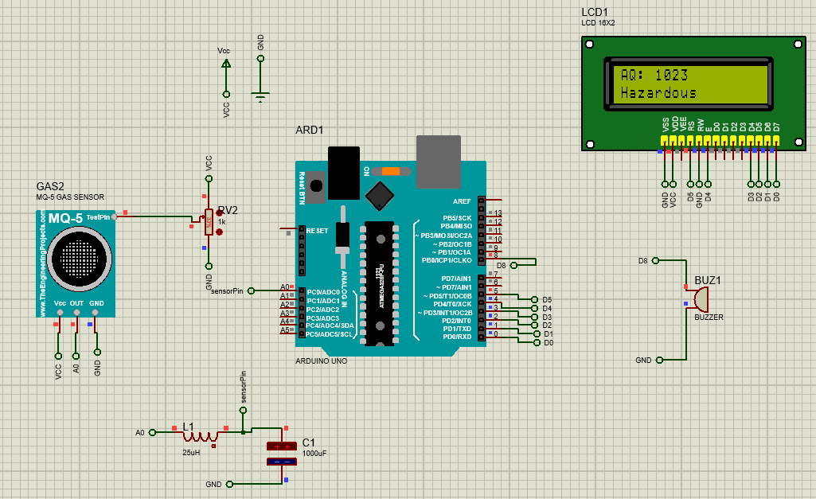

Figure 4: Proteus Simulation When AQI is Hazardous

As shown in Figures 3 and 4, when the code starts running, the Arduino microcontroller begins monitoring the air quality by continuously reading data from the potentiometer, which simulates the gas sensor output. The potentiometer provides an analog value representing the gas concentration in the surrounding environment, and this value is sent to the Arduino. Based on this reading, the system updates the LCD display and controls the alert component (buzzer).
When the air quality is within the safe range (Figure 3), the Arduino displays the gas concentration value on the LCD along with the message “Safe & Clean”. In this condition, the buzzer remains OFF, indicating that the air quality is safe and no alert is required.
When the gas concentration increases and crosses the predefined threshold level (Figure 4), the Arduino identifies the air quality as unsafe. In response, the LCD displays the message “Hazardous” along with the gas value. At the same time, the buzzer is activated, confirming that the air quality has reached a dangerous level and immediate attention is required.

Conclusion:
The primary objective of this experiment was to design and implement a microcontroller-based air quality monitoring system capable of detecting harmful gas concentrations and providing timely alerts to ensure environmental and human safety. The system successfully demonstrated how embedded sensor-based monitoring can be applied for pollution detection and hazard prevention.
Through this experiment, practical knowledge was gained on gas sensor interfacing, analog signal processing, and real-time data monitoring using Arduino. The experiment enhanced understanding of threshold-based alert systems, LCD interfacing, and embedded system programming. It also improved skills in circuit design, algorithm implementation, and environmental monitoring applications, strengthening overall concepts of sensor-based embedded systems.

Reference:
[1] Proteus Design Suite, “How to Simulate Arduino Projects in Proteus,” Labcenter Electronics. [Online]. Available: https://www.labcenter.com
[Accessed: May 5, 2025].
[2] AIUB Microprocessor and Embedded Systems Lab Manual’s

